THE CIRCUIT RIDING LADY PREACHER
On any Friday night in 1933, a diminutive lady with a stern and determined air could be seen arriving in Belvidere in the car of one of the elders from the Phillipsburg Gospel Tabernacle Church. She was their lady preacher, Juliabelle G. Murphy, and she was about to preach in her other charge.
Mrs. Murphy had accepted Christ as her Savior at a camp meeting in New Jersey in her teens. As a young woman, she played the pipe organ in a Methodist Church. In 1903, she entered the Missionary Training Institute at Nyack, where she majored in music and Bible. Dr. A.B. Simpson was one of her teachers. When she went to Nyack, she suffered from a kidney ailment and was assumed not to have long to live. One day in answer to prayer, the Lord touched her body and gave her the precious promise, “you will not die, but live”. From then on through her long life, her main desire was to bring people to Christ.
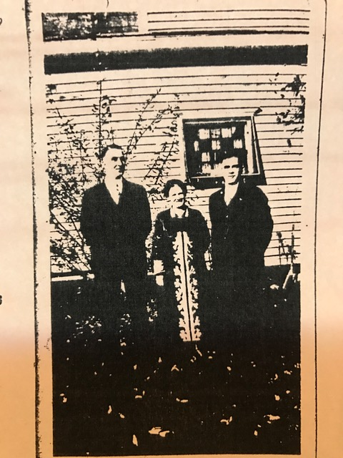
In 1925, she was a worker in the Bosworth campaign’s in Allentown. These meetings resulted in many making decisions for Christ. At the close of the meetings, Mrs. Murphy remained in the area to do follow up among the converts. By writing letters to all who had signed decision cards, she could bring these people together and form the nucleus of a church. Within a year, the Phillipsburg Gospel Tabernacle was a flourishing church with 84 regular attenders and she then turned her attention to Belvidere. Here also she could gather a nucleus of believers and this also led to the opening of a new church. During her ministry in Phillipsburg, a cottage prayer meeting in Washington was begun with the hope of it also becoming a church. An outstation was also formed in Brainards. When she left Warren County, she and her daughter Marguerite, opened a book store in Kentucky. Soon after, Marguerite went to Southeast Asia as a missionary.
Mrs. Murphy moved on to other ministries, including twenty-five years of service in Media, Pa. At the age of eighty-five, she reluctantly left the ministry due to illness. In 1977, she went to live with her daughter and son-in-law in Beulah, Ohio. On June 20, 1977, just one month before her ninetieth birthday, Juliabelle Murphy entered the presence of the Lord. Her obituary recorded, “Through all her lifetime—by visitation, bible studies, prayer meetings, private counselling and the sale of Christian literature—she was instrumental in giving forth the Word of God.

Rev. Samuel W. McGarvey, Evangelist;
Mrs. Juliabelle G. Murphy, Pastor;
Mr. Herbert Sweet, Vocalist

